**DAILY ONLINE ACTIVITIES SUMMARY**

|  |  |  |  |  |  |  |  |  |
| --- | --- | --- | --- | --- | --- | --- | --- | --- |
| **Date:** | **28/05/2020** | | | | | **Name:** | **PRANEETA P HANDRAL** | |
| **Sem & Sec** | **4thSEM. & ‘B’ SEC.** | | | | | **USN:** | **4AL19CS401** | |
| **Online Test Summary** | | | | | | | | |
| **Subject** | | **MICRO-CONTROLLER AND EMBEDDED SYSTEMS** | | | | | | |
| **Max. Marks** | | **20** | | **Score** | | | **19** | |
| **Certification Course Summary** | | | | | | | | |
| **Course** | **Python for Machine Learning** | | | | | | | |
| **Certificate Provider** | | | **Greatlearning Academy** | | **Duration** | | | **5 Hrs.** |
| **Coding Challenges** | | | | | | | | |
| **Problem Statement: In an array X of size M where the array elements contain values from 1 to M with duplicates, the task is to find total number of sub arrays which start and end with the same element.** | | | | | | | | |
| **Status:** **Executed.** | | | | | | | | |
| **Uploaded the report in Github** | | | | | **Yes** | | | |
| **If yes Repository name** | | | | | **LockdownCoding** | | | |
| **Uploaded the report in slack** | | | | | **Yes** | | | |

**Online Test Summary:** 18CS44 test was scheduled from 12:00 pm to 12:40 pm .The portion for the IA was 2nd module there were 20 questions and the time assigned was 40 minutes the questions were mcq type. There were 30 questions of 1 marks respectively.

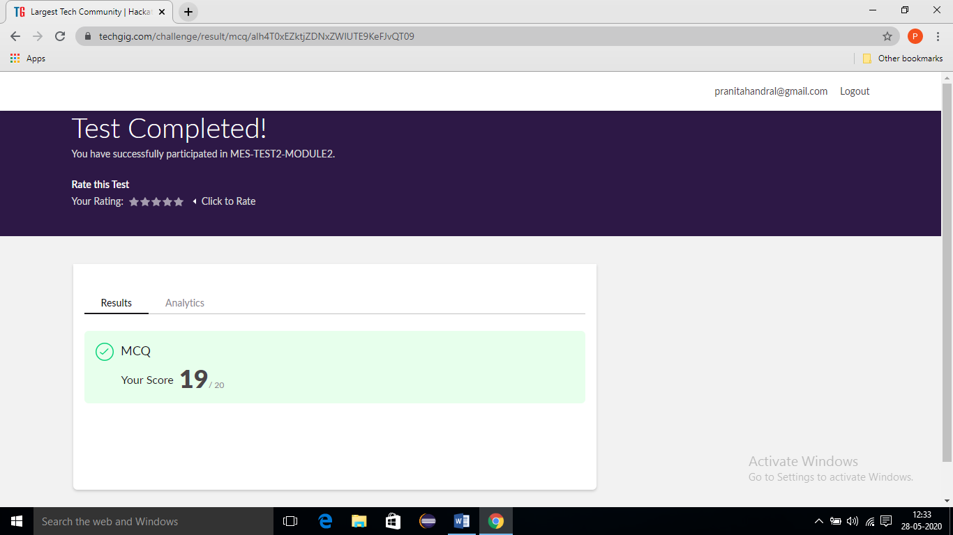

**Online Certification Course Summary:** Today I have learnt about Pandas and execute the code and to achieve the output and some of the basic Pandas programs. pandas is a software library written for the Python programming language for data manipulation and analysis.

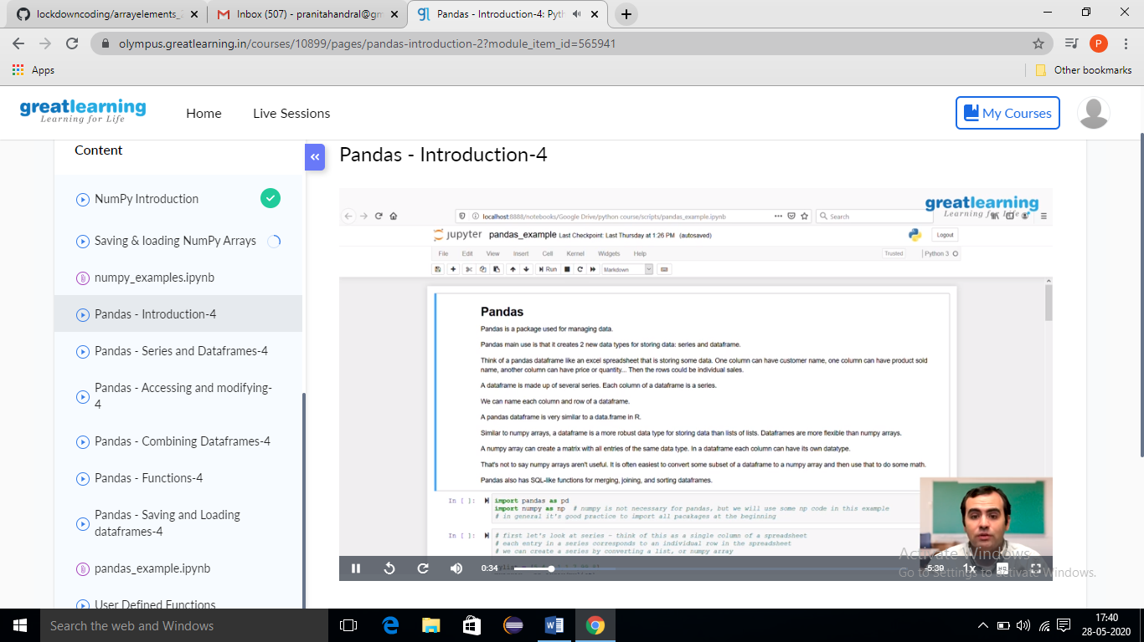

**Online Coding Summary:** Today I received one program from Prof.Vasudev CSE Dept. The program is mentioned above. to my GitHub repository and I’ve shared the snapshot below.

